**Trustee Member Profiles 2022**

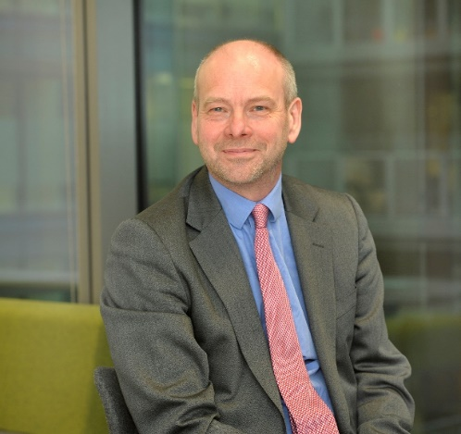

**Phil Morgan (Chair)**

I have been Chair of Healthwatch Salford for 7 years and my work and my passion is empowering people.

I work with social landlords and tenants on promoting tenant scrutiny and involvement. I was formerly Chief Executive of TPAS (Tenants' Participation Advisory Service) for 10 years and a senior housing regulator. Currently, I am on the Board of the Guinness Partnership and was previously a Board Member of New Prospect Housing in Salford.

I have always volunteered. This included being Chair of Governors of Old Trafford Community School, leading it from special measures to one of the most improved schools in the country.

I am looking forward to chairing Healthwatch Salford again and ensuring it speaks for Salford residents.

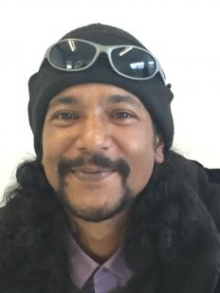**J Ahmed**

With the changing landscape in Greater Manchester's health and social care, I am keen to ensure that Salford maintains and develops a constantly improving health and social care system that fits the needs of the Salford communities and provides greater equality in access and outcomes.

This, I feel, is best achieved by finding creative ways to listen to people and refine services based on their collective experiences.

When I’m not being a carer I spend time on my allotment, where I grow organic fruit and vegetables and take part in the care of the communal hens. I also enjoy spending time with my dog and going on long walks with her.

I think that Healthwatch should have a critical role to play in ensuring that the voices of local people are heard and making sure that they influence the shaping and delivery of health and social care services across the city. I’m looking forward to being a part of that process and to contributing to improving services for Salford.

**Rimpy Batta**

I joined the Board of Trustee’s at Healthwatch Salford in April 2021. I Chair the Finance Committee and am the LINK Trustee for Primary and Secondary Care User Engagement and support Mental Health. I am a member of Healthwatch in Greater Manchester Conflict Resolution Panel and have worked with Healthwatch England in developing their offer of addressing issues of Equality, Diversity and Inclusion at Board level.

I have considerable experience in service transformation, workforce and organisational development, improvement of integrated care pathways and policy implementation. I have led innovative projects and created credible partnerships to deliver quality services for vulnerable people, including specific projects for hard-to-reach groups. I am keen to demonstrate the needs of user and carer groups as equal partners in service design and delivery. I have good insight and experience of the support offer that local Healthwatch partnerships can deliver within Integrated Care Systems.

**Nisa Khan**

Nisa is a qualified Pharmacist and has over 11 years experience working in the NHS, most of which involved leading pharmacy clinical trials services.

Nisa brings experience of service improvement, project management, strategy, risk management and corporate communication.

She also has experience as a Trustee at Together Dementia Support, a charity which delivers services to people living with dementia in the community.

**Yen Siang Tan**

I work as the Operations Manager of Voluntary Sector North West (VSNW), a membership organisation that connects to the region’s voluntary, community and social enterprise (VCSE) sector through infrastructure organisations, equalities networks and large regional and national providers.

Prior to this role, I was the Chief Executive Officer of a charity for over 5 years, to support and empower people to overcome barriers and achieve better lives. I have extensive experience in taking a strategic lead on the development and growth of an organisation, community development and engagement, digital inclusion, project management and service improvement. I am also a current Board of Trustee of Salford CVS.

As someone who is passionate about users and community engagement, I believe users’ voices, if listened to and acted upon, will help ensure services are developed and adjusted, to meet the needs and best interests of the users. Sitting on the Board of Healthwatch Salford will give me an opportunity to be part of the local health and social care champion who is striving to support a health and social care system that is accessible and equitable for everyone and ensure voices of patients are listened to and taken onboard to influence services, policies and decision making.