#whatmatters2u
Priorities Survey 2018
June 2018

[Intentionally blank]

Contents

Background 3
Summary 4

Planning and delivery 5
Engagement 6

Results - Question 1 'What areas of health and care are important to you' 7
Results - Question 2 'What subject themes should Healthwatch Salford look at' 10
Results - Detailed Feedback 13

Next steps 14

Background

Healthwatch Salford is the independent consumer champion for children, young people and adults who use health and social care services in the borough of Salford.

Healthwatch Salford:
- Provides people with information, advice and support about local health and social care services
- Listens to the views and experiences of local people about the way health and social care services are commissioned and delivered
- Uses views and experiences to improve the way services are designed and delivered
- Influences how services are set up and commissioned by having a seat on the local Health and Wellbeing Board
- Passes information and recommendations to Healthwatch England and the Care Quality Commission

Each year, to make sure that we are focussing our activities in the areas that are important to the people of Salford, we carry out a priorities survey. The results of which help to inform us where the direction of our business plan and work should travel towards.

Summary

This year’s annual priority survey ran from 9th April through to the 18th May 2018.

Following completion of the survey and analysis of the scores and individual comments it was apparent that Primary Care service (GP’s & Dentist’s) was valued as the most important health and care category to the people of Salford. This was followed a close second with Secondary Care (Hospitals).

In relation to what people feel Healthwatch Salford should look more closely at, Access to appointments came up on top with waiting times for appointments second.

The top 5 areas of health and care that are important

- Primary Care (Doctors & dentists)
- Secondary Care (Hospitals)
- Community Care (Pharmacies, Opticians, etc)
- Public Health (Health promotions, vaccs etc)
- Mental Health (Adults and children)

The top 5 subjects that Healthwatch Salford should look into

- Access to appointments
- Waiting times
- Communication
- Consultation times
- Staff attitudes and training

Planning & Delivery

A basic draft version for a survey was put together with 11 staff and volunteers coming together at a planning meeting earlier in March 2018. At this meeting, round table discussions took place as to the type of questions we needed to ask and the audience the surveys needed to be targeted at. It was agreed to offer participants a quick and easy to use method of scoring predetermined categories of heath, care and subject matters depending on how important they felt each one was to them. There was also the option for participants to be able to add in their own category/subject if they felt appropriate. Whilst this approach would give us a quantitative response, participants were further invited to leave more detailed feedback which could provide us with some real life qualitative intelligence.

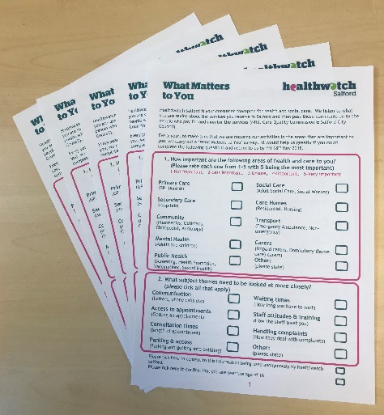
The survey was then made available in 3 formats: a double sided A4 form with the main survey categories on one side and a reduced version of the ‘Feedback Form’ on the reverse for people to leave more detailed feedback on individual services; an A5 card with the survey on one side and our freepost details on the other (this facilitated the ease for participants to quickly fill out the form and put into the post); finally, there was the online version using the Survey Monkey platform.

Engagement events were set up to run 2 x 3-hour sessions at each of the gateways across Salford: Eccles, Swinton, Walkden, Pendleton & Broughton Hub. Salford Royal hospital also welcomed us to host a stand within a busy part of the hospital to capture the views of staff, patients and visitors. In addition, staff and volunteers took copies of the surveys out to local groups and meetings that they were attending.

Both Salford Royal NHS Foundation Trust and Salford University were key partners in sharing the message of the survey through social media which in turn generated a huge number of responses through to Survey Monkey.

Engagement activity

- Staff and volunteers attended 25 venues and events across Salford, 16 of which were planned and hosted by Healthwatch Salford

- 671 surveys were completed (400 on paper/card and 271 online)

- We spoke to 703 people about the survey and Healthwatch in general

- 6,897 people and organisations were reached by our own social media campaign in Twitter and Facebook

- In total, we spent 105 hours engaging with the public

- 67 people gave us further detailed feedback on individual services

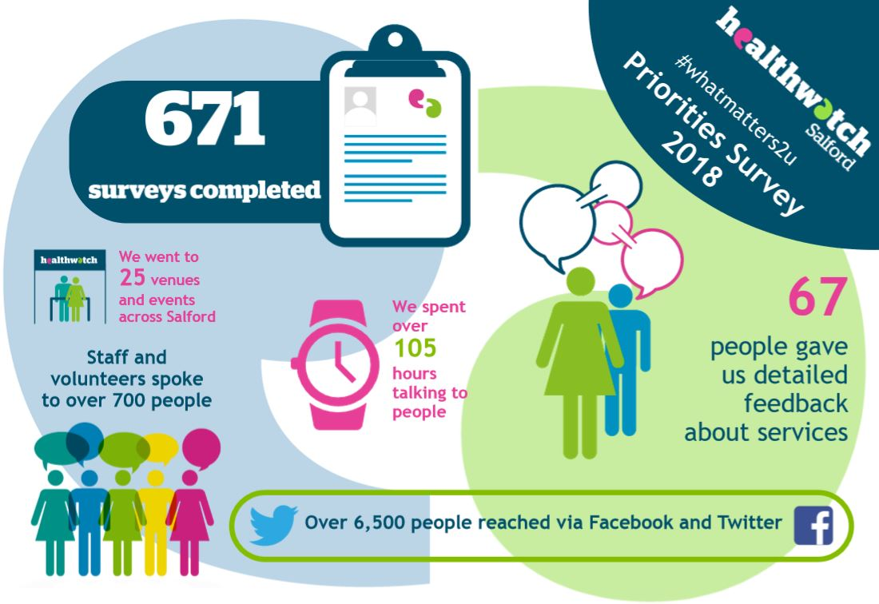

Results

We had a good response to the survey with 671 people completing the survey within the timeframe allowed.

Question 1 - How important are the following areas of health and care to you?

We asked participants to score each service with a rating from 1 to 5 (1-Not important, 2-Less important, 3-Unsure, 4-Important & 5-Very important), however not everybody completed a score for each service:

 | Number of participants who scored
Service | Paper | Online | Total | %
Primary Care (GP, Dentist) | 386 | 271 | 657 | 98%
Secondary Care (Hospitals) | 381 | 263 | 644 | 96%
Community (Pharmacies, Opticians, Chiropodist, Audiology etc) | 364 | 270 | 634 | 94%
Mental Health (Adults and Children) | 357 | 266 | 623 | 93%
Public Health (Screening, Health Promotion, Vaccinations, Sexual Health etc) | 355 | 269 | 624 | 93%
Social Care (Adult Social Care, Social Worker etc) | 351 | 266 | 617 | 92%
Transport (Emergency Ambulance, Non-emergency ambulance) | 342 | 269 | 611 | 91%
Carers (Unpaid carers, Domiciliary (home care) carers) | 338 | 267 | 605 | 90%
Care Homes (Residential and Nursing) | 334 | 265 | 599 | 89%
Other (participant free text comment) | 13 | 68 | 81 | 12%

Scores were totalled for each category with the idea that the higher the number, the more important that area of health or care was to people.

As there was a small data difference in terms of how many people had scored a category vs the total amount of scores for each, we decided the fairest way to analyse this question would be to count the total number of people who had scored ‘important’ or ‘very important’ for each category.

The results of these findings determined the ranking in terms of importance and are as follows:

Primary Care | 597
Secondary Care | 592
Community | 505
Public Health | 503
Mental Health | 496
Transport | 485
Social Care | 474
Carers | 447
Care Homes | 435
Other | 42

In addition, participants were able to leave their own free text comment or service suggestion if they felt it wasn’t represented:
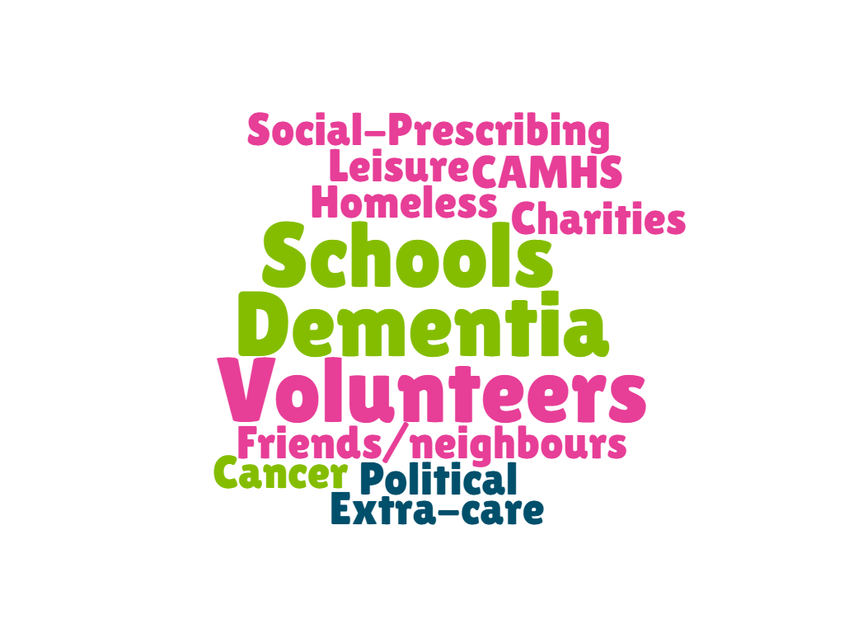

List of free text comments to question 1
Accessibility of care with better communication between different providers
Air quality
alternative therapies with non- pharmaceutical interventions
Asperger’s/HFA diagnosis and support
CAMHS
charities
Chemist opening times
Communication between all the above agencies and communication with patients eg a patient leaving A&E after retention and catheterisation needs to know where catheter bags are obtainable and how to contact a District Nurse etc.
Community awareness/liaison
Counselling
Dementia, Cancer - day centre and/or hospices/respite
Dentist’s & opticians
District Nurses
Drug & Alcohol services
Emergency transport is important. Non-emergency less so
Employment opportunities
Extra care facilitation and support
Friends/neighbours
getting to see a GP without having to wait for two weeks
Health promotion schemes
Healthy lifestyle
Homeless people service
Hospital after care
I don’t need the last 4 points at the moment, but I feel they are still important for others plus I may need them in the future, so they will then be very important
It's hard to distinguish between these - they have different levels of priority at different times for different people, depending on their circumstances and immediate needs.
Joined-up services.
Leisure centres
Links between the above services to enable patient ease of access through the system
Meals on wheels companies
Medication on repeat
More care from various services after a person is discharged from hospital
More input to monitoring medication. Quantities issued and tighter control.
N/A
people who care for family at home so they can stay in their own homes there are lots of family's doing it but they don't get help and they are very important to GPS and the bus because they do a very good job and only for these people the bus and GP would have a lot more to do and if people can be looked after at home it doesn't cost the government half as much money as it is over a 1000 pound a week for someone to be in a care home it should be looked in to more
Political issues
public volunteers
Regular check-ups by GP
Schools
Schools including primary and secondary education
Single person living on their own unable to afford their own care
Social groups providing activities for dementia patients
Social Prescribing
The abundance of health improvement teams that multiply by the month
Treating the patient as a person not a number or commodity
Using peoples preferred method of communication
Volunteers
waiting time at hospital

Question 2 – What subject themes should Healthwatch Salford look at more closely?

The survey then went onto ask a second question about what people thought Healthwatch Salford should be looking at more closely. Rather than ranking each, participants were asked to tick the ones they felt appropriate:

Service | Paper | Online | Total | %
Access to appointments (Getting an appointment) | 331 | 210 | 541 | 81%
Waiting times (How long you have to wait) | 299 | 175 | 474 | 71%
Communication (Letters, phone calls, emails, posters etc) | 249 | 139 | 388 | 58%
Consultation times (Length of appointment) | 255 | 119 | 374 | 56%
Staff attitudes and training (How the staff treat you) | 234 | 115 | 349 | 52%
Parking and access (Parking and getting into the building) | 211 | 134 | 345 | 51%
Handling Complaints (How they deal with your complaints) | 191 | 66 | 257 | 38%
Other (participant free text comment) | 18 | 25 | 43 | 6%

As with the first question, they were also given the option to leave a free text comment if they felt a subject had not been suggested:

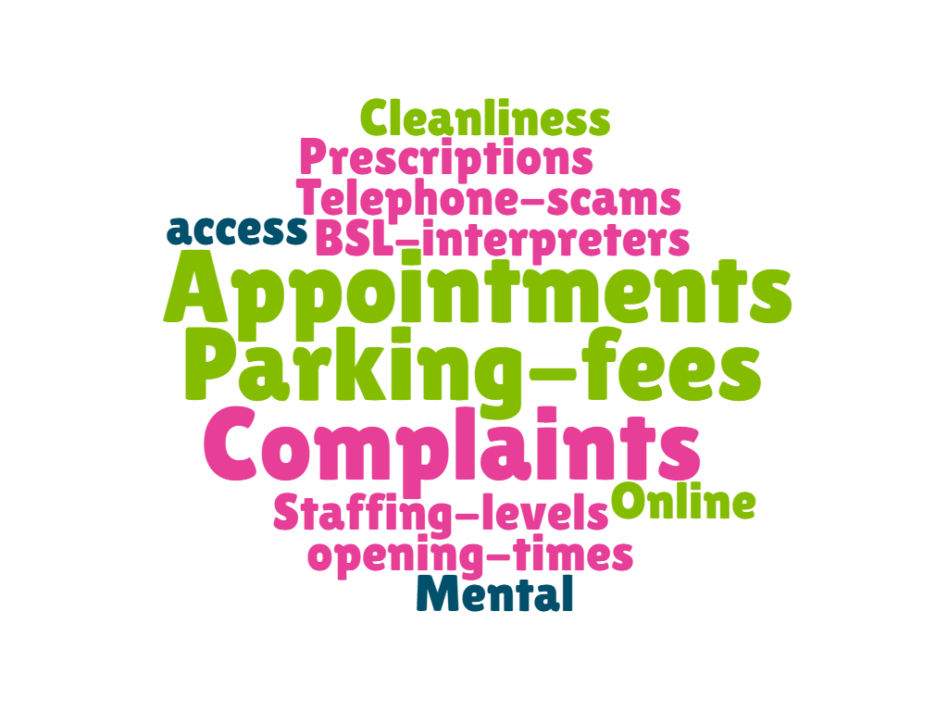
List of free text comments to question 2
Access for BSL users interpreters
access to out of hours mental health services
Can never get Doctors’ appointments
Care in care homes
Cleanliness of buildings and surrounding areas
Complaints are dealt with in a dismissive attitude in a culture of staff being generally dismissive towards patients
Confusing automated system
Creating appropriate care plan with patient
Ease of process of making a complaint almost impossible at Salford Royal
End privatisation stop cuts
GP appointments for working people. It’s impossible unless you know 2 weeks before that you will need to ask for a day off. Weekend GP surgery for working people ONLY would be ideal
GP opening times
Having someone to ask advice, to save time.
Hospital Parking Fee
Housing
Housing
Housing
I find people treat you as they are treated
I recently had a Fracture Clinic appointment which felt very rushed and I couldn’t absorb all I was being told.
I think many things need looking at, but it is not all aspects of these areas that need looking at for example with staff attitudes, many staff are fantastic, it is just a few who need additional training on how they speak to/treat patients.
Making people like me who have bad legs can get to the doctors and can afford the transport
making waiting areas welcoming and comfortable.
Mental health training!!
Not sure this is Salford's concern or NHS but letters come for appointments after the date, letters are duplicated. Admin seems to be not as efficient as other areas.
Often it is the reception/admin staff that are very unhelpful or rude, and you always need to speak to them first to get through to the specialist, and this can be a big barrier. I appreciate you need this setup, it is just that the reception staff could be more helpful/kind.
Online access to these services
Parking is a nightmare at the hospital
Parking and access needs to include cycling, walking and public transport. Many people do not want to or don’t have the option of travelling by car and more sustainable modes need to be catered to and promoted in communication about appointments etc
Patients self help
peak time appointments [traffic]
Person centred services available locally
Prescription system - new system takes too long
Receptionist in all areas
Salford hospital receptionists who aren’t customer friendly
Screening
Should have certificates and qualifications to show and ID
Simple information sheets with telephone numbers for contact from every department where applicable, an A4 sheet detailing next steps
Staffing levels - an awful lot of agency works are used which effects person centred care
Telephone scams
The appointment for referral appointment is waste of time; unnecessary bureaucracy.
The cost of hospital parking
there isn’t any empathy anymore you feel like you’re on a conveyer belt next please explaining to you what is key and understanding people are rushed and don't understand what is wrong with them and still in this day not everybody especially the elderly haven’t got access to the internet
why are vending machines in A&E waiting are so expensive?

Further comments received on individual services

In addition to the 671 surveys that were completed, 101 people also left more detailed feedback about individual services. Upon further analysis it was determined that following a couple of engagement exercises at HMP Forest Bank many of the detailed comments related directly to the prison healthcare and not to that of general public services out in the community. As this potentially skewed the qualitative data it was decided to remove these comments as part of this priorities exercise and produce a separate report for the management team at HMP Forest Bank.

The remaining comments (67) were read through, sentiments noted and then categorised into different service sections which mirrored the main survey.

Each comment was then further graded to sit within a subject theme, again aligning to the main survey. The results of this analysis are as follows:

Sentiment of comments
☺  32  Positive | 😐  5  Neutral | ☹  30  Negative

Services that people talked about
Service | Comments | Positive | Neutral | Negative
Primary Care | 26 | 11 | 2 | 13
Secondary care | 24 | 15 | 2 | 7
Mental health | 7 |  | 1 | 6
Support services | 4 | 4
Transport | 3 |  |  | 3
Community | 1 |  |  | 1
Public Health | 1 | 1
Education (Schools) | 1 |  |  | 1

Subject themes that people talked about
Service | Comments | Positive | Neutral | Negative
Access to Appointments | 8 | 4 | 1 | 3
Communication | 4 | 1 |  | 3
Consultation times | 1 |  |  | 1
Overall service | 25 | 12 | 3 | 10
Staff | 22 | 15 | 1 | 6
Waiting times | 5 |  |  | 5
Medication | 2 |  |  | 2
Access to Appointments | 8 | 4 | 1 | 3

“In their own words” - what did people say?

Primary Care (GP & Dentist)
Access to appointments
☺ | My own GP gives me same day appts, never struggle with myself or children
 | Always good with getting appointments around work hours. Some issues with consistencies "I'll call to check how you're getting on with your meds" - no call
 | My experience with Walkden Gateway is good actually. The appointment was on time and everything was explained to me. It was good
😐 | Everything is great except for this new appointment time thing changing over to computers from paper prescriptions
☹ | Can be 3-4 weeks for appointments
 | This surgery should go back to the old way where you are assigned your own GP, instead of it being a walk-in centre and seeing the first available one. You used to be able to get an appointment within a week/few day, now you can't get one in less than a month
Communication
☺ | Won't take appointment [with BSL user] without interpreter, Dr Tankel Clarendon Surgery.
☹ | Can’t get an emergency Appointment - have to wait 3 days if interpreter is needed. Not fair, not equal with hearing people.
Consultation times
☹ | Having several chronic illnesses, it is difficulty to discuss all issues in one appointment and feel rushed through appointment. Some things are put off for another appointment. Would be better for a longer appointment rather than two.
Overall service
☺ | My body is ok, I can hear everything, but I couldn't speak when it happened. I had speech therapy every day at the unit at first, now only one hour on a Monday. I had asked the person who was seeing to me - is there anything can help me to speak faster. Now I go 10-12.20 Wednesday, one therapist to 10 people, it's very good.
 | Good experience
 | Never let me down before
☹ | Got a letter from my GP - please book an appointment. I keep trying to ring - got an answerphone 'you're 5th in the queue!' When I finally got through I was asked for a password. I didn't have a password! I had to go back to my GP for the password. When I rang back and gave my password I was told that there were no appointments left.
 | Daughter was brought in over a period of 6 months to be told viral infection and sent away. Turned out stage 4 lymphoma which I kept saying things were wrong
 | I make appointment to see GP for 3pm and don't get to see GP until 3.30pm to 3.34pm
 | I feel that more emphasis is placed on getting you access to healthcare if you are homeless in Salford
 | Lots of appointments but only give same treatment. Not referred on for 3 years, not happy. Not done anything. It's not good for my health, affected my liver.
Staff
☺ | Clarendon surgery has fantastic doctors, took best care one could wish for
 | Receptionists are polite, professional and receptive. Nursing staff and GP's are caring, highly professional, friendly and consistent. I have always been able to obtain appointments promptly
 | I can't say anything bad about this place. I've been well looked after, still am. Nurses come 5 days a week. I believe in helping yourself as well. Eating good food, not junk food. I had four children and I always cooked, I worked hard
 | Our family doctor’s surgery is very busy, but all the staff are always friendly, approachable, patient and very professional. We know we are in good hands!
 | Superb, couldn't get better. They are nice, good at job, don't keep waiting long.
😐 | My GP is very understanding of mental health conditions and is supportive when it comes to dealing with them. He could however, be more proactive with facilitating access to counselling rather than just relying on medication to treat the condition.
☹ | Getting past the receptionist is the hardest thing I go through
 | Receptionist poorly trained - no compassion
Waiting times
☹ | Had to wait over 24hrs for prescription which was too long, as I was in extremely bad pain

Secondary Care (Hospitals)
Access to appointments
☺ | Very quick and follow up appointments always on time
Communication
☹ | Last October I needed neurology appointment because my epilepsy was getting worse. I turned up 3 times and the interpreter wasn't there.
Medications
☹ | I had a terrible itchy rash for 3 months because of the biologic drug Toxilizumab. It was agony. These biologics should not be given to people until a lot more research has been done. They do not know what suffering they cause.
Overall service
☺ | I received/suffered blast trauma hearing during the 1940 blitz when I was a baby of 10 months of age. I experience difficulty hearing speech (often bad diction)
 | When I was injured I needed these services. While in the military I was injured and need a lot of support. Without the health service I would have died
 | Very good, personalised and well informed
 | Care was excellent, outstanding!
 | Experience here and at Stepping Hill has been marvellous
 | Hospital, GP, Podiatrist all do as I expect them, they are just doing their job. All satisfactory
😐 | Average
 | Great initially, poor information to companion partner - no option in dealing with unknown problem. Rapid brain tumour - will progress. Initially predicted 10 + years, then dropped to 5 years after results - do not give fake results - give a range. Poor responses to rapid deterioration until retreated. I and my partner are both referral partners given insufficient by the medics involved.
☹ | Late appointment because of parking
Staff
☺ | Took my mum to have MRI scan, she was scared but the nurse on duty soon calmed her and had her laughing. Mum felt relaxed with nurse joking, making mum laugh in ward.
 | Staff were very good and helpful and kind. I have a difficulty communicating and the staff took their time to listen and understand me
 | I have always found the staff to be very caring and kind. Need more disabled parking, took 45 minutes to find even an ordinary car parking space.
 | A long stay in unpleasant environment has been made bearable by the amazing staff. Their commitment to care has been outstanding
 | Very accessible Dr in sleep clinic Dr Murphy. In and out of clinic. Not too bad to come to
 | After going to Leeds/Bradford/Harrogate and private, the best care all round has come from the neurologist Dr Murphy at Salford. All staff at the hospital are friendly and helpful.
 | Really attentive - consultants secretary very helpful
 | Staff seed to be very happy in their jobs and were very kind at a time when I was very poorly.
☹ | A few years ago, as an inpatient, I had an unpleasant experience with a member of staff who had a very taciturn and negative attitude. I found it impossible to lodge a complaint by email or form on the website. I suspect the hospital deliberately makes none available to encourage people to give up and go away
 | Two male doctors were rude and then a female nurse joined in. I was scared. Both Daughters complained, and I got a letter apologising, but it was rubbish!
 | Poor assessment due to physio rushing despite me being on time. Gave me a few excuses and a stretchy band. Difficulty getting a reasonable time slot. Poor attitude from some member of staff who are almost dismissive - found private physio support to help me after my op.
Waiting times
☹ | I have a jejunostomy feeding tube. When it needs changing, I usually phone GI Radiology and book a time to come to the dept. The procedure itself takes about 30 mins. I’m "in and out" of hospital within the hour. This system has worked well for the last 3 years. Last week I phoned the dept to be told that I could no longer arrange the tube change myself and must ask my GP to send a written referral. Once received, a member of the team would be in touch to arrange an appt. This has now introduced an additional level of bureaucracy through which I must mine before an appt is secured. It is adding to the workload of my already overworked GP surgery. I informed my GP receptionist of the new procedure. Still waiting for an appt 10 days later!

Mental Health Services
Access to appointments
☹ | I need more help with my health. I need more help with my depression
Communication
☹ | My wife’s appointment and communication with mental health service was very poor. Mainly the communication was poor throughout
Overall service
😐 | Need more one on one meetings. Also, could do with more help in the local community
☹ | Told by GP to basically go to A&E
 | Keep being referred to A&E
Staff
☹ | Lack of money - lack of care. Junior Doctor making notes in the corner rolling his eyes, rude.
Waiting times
☹ | Long waiting times then poor service

Support Services
Overall service
☺ | I use the services of Loaves and Fishes, mental health and drug and alcohol (Achieve). I couldn't live my life how I do without these services
 | I visit Loaves & Fishes (Salford) Mon, Tue, Wed, Thu. I find this good place to meet people, get advice, get food, drinks, able to get to see CAB
Staff
☺ | I find these ladies not just 'caring' but friends. I welcome them each week and find the shared knowledge very useful and usually the 'right' solution to a problem or a problem avoided. A good team definitely worth joining!!
 | My experience with Salford Loaves and Fishes is only one of positivity. All the staff are very friendly and polite and are also willing to help you. This is a good service

Transport
Overall service
☹ | Bus service in Kersal/Manchester terrible - one bus stop race course going to Bury you take your life in your hands trying to get the bus to stop between parked cars
Waiting times
☹ | Had to wait 4 hours to get back to hospital with broken pelvis and fractured back
 | An ambulance was called for my friend - pregnant - went into labour. Took a long time - nearly gave birth in the street

Community (Pharmacies)
Medications
☹ | Well Pharmacy in Eccles put the wrong dose of medication in blister packs - led to a seizure. Very apologetic but it is a problem.

Public Health
Overall service
☺ | Needs to be recognised more

Education (Schools)
Overall service
☹ | [Secondary School in Salford] - Dyspraxia for son, no assistance provided for 2 1/2 years. SIASS referral

Next Steps

